Dear Families,
We have some very exciting news! The PTO has generously offered to purchase the class t-shirts for our students. We are able to use a local company so we should be able to get the t-shirts within two weeks after ordering them. This means ALL of our students will be able to have a class t-shirt to wear on special days, field trips, assemblies, and to have as a keepsake from Kindergarten. If you sent money in previously, it is attached to this letter.

Please fill out the bottom portion and return it to your child’s teacher so we know your child’s size (We know that a lot of you already gave your child’s t-shirt size, but we are asking everyone to give it to us again). Also, if any adults would like to order a t-shirt, you can still do so. Just fill out the box below and return with you payment.
Thank you!
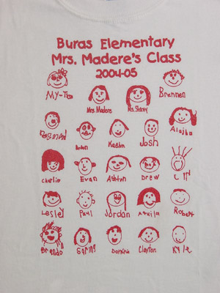
SAMPLE

Student _____________________

Teacher_____________________
Total number of shirts ordered ____

Total paid $________
(only for additional shirts)

Adult Sizes
$5.30 $7.15
__ Small __ XXL
__ Medium __ XXXL
__ Large
__ X-Large

Youth Sizes
$5.30
(only for additional shirts)
__ S (6-8)
__ M (10-12)
__ L (14-16)
__ XL (18-20)

